**Chapter 1: Introduction**

**1.1 Problem Formulation:**

In this day and age where presence in the virtual world is an imperative, small restaurants and entrepreneurs too need to take benefit of it. Online food ordering websites present just the options. Today every offline industry is following the online system, it is assumed that online food delivery would increase by 30% yearly from 2017 to 2022 across the world. The online food ordering system for restaurants is a trend which is growing at a fast pace. Major Restaurants today just for the convenience factor and increasing revenue are listing their services even online.

This is due to the fact that adoption for the mobile technology has increased in leaps and bounds in the world. Phone orders and booking rates have declined extraordinarily these days. Mobile apps developed to dedicatedly provide food ordering is now a raging trend for all mobile users. Online pizza ordering systems give you permanent control of your restaurant’s ordering process. Once you set up your website, your business has all it needs to become a force to be reckoned with in the industry.

Customers love the technology, because it allows them to order in their favorite foods, which they can enjoy at will from the comfort of their homes or from other locations of their choice. Every major city has at least one online food ordering and delivery system. Since people are not willing to waste their time in restaurants to have free tables, they just start to order the food in web and mobile apps. As majority of people use the apps to order the foods, online food ordering system has a good future.

The purpose of Pizza Ordering System is to automate the existing system by the help of computerized equipment and full-fledged computer software, fulfilling their requirements, so that their valuable data/Information can be stored for a longer period with easy accessing and manipulation of the same. The required software and hardware are easily available and easy to work with.

Pizza Ordering System, as described above, can lead to error free, secure, reliable end fast management system. It can assist the user to concentrate on their other activities rather to concentrate on the record keeping. Thus it will help organization in batter utilization of resources. The organization can maintain computerized records without redundant entries. That means that one need not be distracted by information that is not relevant, while being able to reach the information.

The Online Pizza Ordering System is a new system that replaces the current manual and telephone processes for ordering and picking up lunches in the modern world. The system makes use of various external entities and system interfaces for efficient operation. The system is expected to evolve over several releases, ultimately connecting to the Internet ordering services for several local restaurants and to credit and debit card authorization services.

**Chapter 2: Software Requirement Specification**

Software Requirements Specification

for

Online Pizza Ordering System

Version 1.0 approved

Prepared by:

Jay Barot

Kaushik Jadhav

Shubham Sawant

<date created>

Table of Contents

Table of Contents 1

1. Introduction 2

1.1 Purpose 2

1.2 Document Conventions 2

1.3 Intended Audience and Reading Suggestions 3

1.4 Product Scope 3

1.5 References 4

2. Overall Description 5

2.1 Product Perspective 5

2.2 Product Functions 5

2.3 User Classes and Characteristics 5

2.4 Operating Environment 7

2.5 Design and Implementation Constraints 7

2.6 User Documentation 7

2.7 Assumptions and Dependencies 7

3. External Interface Requirements 8

3.1 User Interfaces 8

3.2 Hardware Interfaces 19

3.3 Software Interfaces 19

3.4 Communications Interfaces 20

4. System Features 21

4.1 Order Meals 21

4.2 Create, View, Modify and Delete Meal Subscriptions 23

5. Other Nonfunctional Requirements 26

5.1 Performance Requirements 26

5.2 Safety Requirements 26

5.3 Security Requirements 26

5.4 Software Quality Attributes 26

6. Other Requirements 27

Appendix A: Glossary 27

Appendix B: Analysis Models 31

# Introduction

## Purpose

The purpose of Pizza Ordering System is to automate the existing system by the help of computerized equipment and full-fledged computer software, fulfilling their requirements, so that their valuable data/Information can be stored for a longer period with easy accessing and manipulation of the same. The required software and hardware are easily available and easy to work with.

Pizza Ordering System, as described above, can lead to error free, secure, reliable end fast management system. It can assist the user to concentrate on their other activities rather to concentrate on the record keeping. Thus it will help organization in batter utilization of resources. The organization can maintain computerized records without redundant entries. That means that one need not be distracted by information that is not relevant, while being able to reach the information

## Document Conventions

We will also use bold letter to emphasis main topics and for all the major functions of the system. Underline will represent hyperlink. Italic will represent acronyms and useful notes.

We will use some acronyms through this document. Abbreviations and definition of some useful terms we will use are given below:

**Table 1: Document Conventions**

|  |  |
| --- | --- |
| **Term** | **Definition** |
| System Admin | System admin is a person who is responsible for managing the whole system and who has full access to the system. |
| System User | A person who is using or operating the system but with a limited privilege. |
| Database | Collection of all the information monitored by this system. |
| Field | A cell within a form. |
| Software Requirements Specification *(SRS)* | A document that completely describes all of the functions of a proposed system and the constraints under which it must operate. For example, this document. |
| Stakeholder | Any person who is involved in the development process of the software. |

## Intended Audience and Reading Suggestions

This document is to be read by the development team, the project managers, marketing staff, testers and documentation writers. Our stakeholders, company manufacturing associated type hardware, company providing embedded operating system, shareholders and distributors who markets the finished product, may review the document to learn about the project and to understand the requirements. The SRS has been organized approximately in order of increasing specificity. The developers and project managers need to become intimately familiar with the SRS.

Others involved need to review the document as such:

**Overall Description** – Marketing staff have to become accustomed to the various product features in order to effectively advertise the product.

**System features** – Testers need an understanding of the system features to develop meaningful test cases and give useful feedback to the developers.

**External Interface Requirements** – The hardware developers need to know the requirements of the device they need to build. The marketing staff also needs to understand the external interface requirements to sell the product by describing the user-friendly features of the system.

**Nonfunctional and Functional Requirements** – The hardware developers.

## Product Scope

In this day and age where presence in the virtual world is an imperative, small restaurants and entrepreneurs too need to take benefit of it. Online food ordering websites present just the options. Today every offline industry is following the online system, it is assumed that online food delivery would increase by 30% yearly from 2017 to 2022 across the world. The online food ordering system for restaurants is a trend which is growing at a fast pace. Major Restaurants today just for the convenience factor and increasing revenue are listing their services even online.

This is due to the fact that adoption for the mobile technology has increased in leaps and bounds in the world. Phone orders and booking rates have declined extraordinarily these days. Mobile apps developed to dedicatedly provide food ordering is now a raging trend for all mobile users. Online pizza ordering systems give you permanent control of your restaurant’s ordering process. Once you set up your website, your business has all it needs to become a force to be reckoned with in the industry.

Customers love the technology, because it allows them to order in their favorite foods, which they can enjoy at will from the comfort of their homes or from other locations of their choice. Every major city has at least one online food ordering and delivery system. Since people are not willing to waste their time in restaurants to have free tables, they just start to order the food in web and mobile apps. As majority of people use the apps to order the foods, online food ordering system has a good future.

## References

[1]. Kirti Bhandge, Tejas Shinde, Dheeraj Ingale, Neeraj Solanki, Reshma Totare,”A Proposed System for Touchpad Based Food Ordering System Using Android Application”, International Journal of Advanced Research in Computer Science Technology (IJARCST 2015).

[2]. Varsha Chavan, Priya Jadhav,Snehal Korade,Priyanka Teli, ”Implementing Customizable Online Food Ordering System Using Web Based Application”, International Journal of Innovative Science, Engineering Technology(IJISET) 2015.

(10:16 26/07/18)

[3]. Resham Shinde, Priyanka Thakare, Neha Dhomne, Sushmita Sarkar, ”Design and Implementation of Digital dining in Restaurants using Android”, International Journal of Advance Research in Computer Science and Management Studies 2014.

(10:16 26/07/18)

[4]. Ashutosh Bhargave, Niranjan Jadhav, Apurva Joshi, Prachi Oke, S. R Lahane,“Digital Ordering System for Restaurant Using Android”, International Journal of Scientific and Research Publications 2013.

(18:20 26/07/18)

[5]. Khairunnisa K., Ayob J., Mohd. Helmy A. Wahab, M. Erdi Ayob, M. Izwan Ayob, M. Afif Ayob, ”The Application of Wireless Food Ordering System” MASAUM Journal of Computing 2009.

(18:25 26/07/18)

[6]. Noor Azah Samsudin, Shamsul Kamal Ahmad Khalid, Mohd Fikry Akmal Mohd Kohar, Zulkifli Senin, Mohd Nor Ihkasan,” A customizable wireless food ordering system with real time customer feedback”, IEEE Symposium on Wireless Technology and Applications(ISWTA) 2011.

(15:17 27/07/18)

[7]. Serhat Murat Alagoza, Haluk Hekimoglub,” A study on tam: analysis of customer attitudes in online food ordering system”, Elsevier Ltd. 2012.

(15:17 27/07/18)

[8]. Patel Krishna, Patel Palak, Raj Nirali, Patel Lalit,” Automated Food Ordering System”, International Journal of Engineering Research and Development (IJERD) 2015.

(15:17 27/07/18)

# Overall Description

## Product Perspective

The Online Pizza Ordering System is a new system that replaces the current manual and telephone processes for ordering and picking up lunches in the modern world. The system makes use of various external entities and system interfaces for efficient operation. The system is expected to evolve over several releases, ultimately connecting to the Internet ordering services for several local restaurants and to credit and debit card authorization services.

## Product Functions:

The Online Pizza Ordering System provides the following features:

* Creating & Changing Issues at ease.
* Ordering your food comfortably sitting at home.
* Cost effective due to periodic discounts and coupons.
* Supports Cashless Economy by online payment transactions.
* Simple Status & Resolutions.
* Multi-level priorities & severities.
* Attachments & Additional Comments far more information.
* Robust database back-end.
* Decrease the l oad of the person involved in existing manual system.
* Access of any information individually.
* Work becomes very speedy.
* Easy to update information.

## User Classes and Characteristics

|  |  |
| --- | --- |
| Patron (favored) | A Patron is an employee at the corporate campus in who wishes to order meals to be delivered from the concerned company. There are about 600 potential Patrons, of which an estimated 400 are expected to use the Pizza Ordering System an average of 4 times per week each. Patrons will sometimes order multiple meals for group events or guests. An estimated 90 percent of orders will be placed using the corporate Intranet, with 10 percent of orders being placed from home. All Patrons have Intranet access from their offices. Some Patrons will wish to set up meal subscriptions, either to have the same meal to be delivered every day or to have the day’s meal special delivered automatically. |

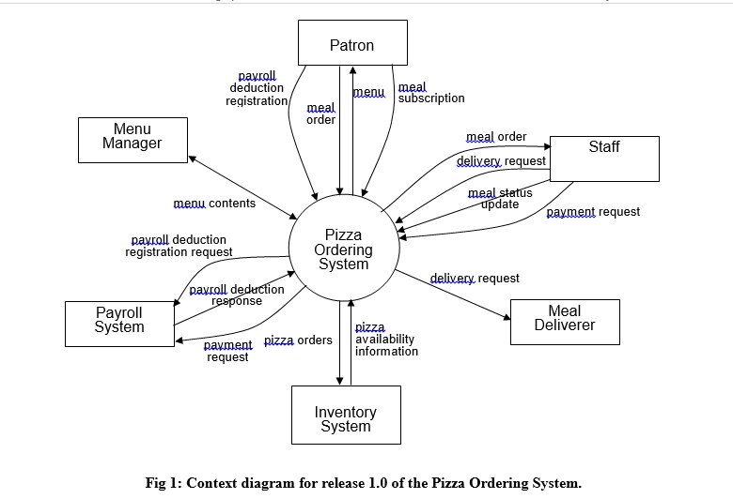

|  |  |
| --- | --- |
| Staff | The company might employs about 20 Staff, who will receive orders from the Pizza Ordering System, prepare meals, package them for delivery, print delivery instructions, and request delivery. Most of the Pizza Staff will need to be trained in the use of the computer, the Web browser, and the Pizza Ordering System. |
| Menu Manager | The Menu Manager is a pizza employee, perhaps the pizza manager, who is responsible for establishing and maintaining daily menus of the food items available from the pizza and the times of day that each item is available. Some menu items may not be available for delivery. The Menu Manager will also define the pizza’s daily specials. The Menu Manager will need to edit the menus periodically to reflect planned food items that are not available or price changes. |
| Meal Deliverer | As the Pizza Staff prepare orders for delivery, they will print delivery instructions and issue delivery requests to the Meal Deliverer, who is either another pizza employee or a contractor. The Meal Deliverer will pick up the food and delivery instructions for each meal and deliver it to the Patron. The Meal Deliverers’ primary interactions with the system will be to reprint the delivery instructions on occasion and to confirm that a meal was (or was not) delivered. |

## Operating Environment

OE-1: The Pizza Ordering System shall operate with the following Web browsers: Microsoft Internet Explorer versions 5.0 and 6.0, Netscape Communicator version 4.7, and Netscape versions 6 and 7.

OE-2: The Pizza Ordering System shall operate on a server running the current corporate approved versions of Red Hat Linux and Apache WebServer.

OE-3: The Pizza Ordering System shall permit user access from the corporate Intranet and, if a user is authorized for outside access through the corporate firewall, from an Internet connection at the user’s home.

## Design and Implementation Constraints

CO-1: The system’s design, code, and maintenance documentation shall conform to the *Institue of Electrical and Electronic Engineer(IEEE) Standard.*

CO-2: The system shall use the current corporate standard Oracle database engine.

CO-3: All HTML code shall conform to the HTML 4.0 standard.

CO-4: All scripts shall be written in Perl.

## User Documentation

UD-1: The system shall provide an online hierarchical and cross-linked help system in HTML that describes and illustrates all system functions.

UD-2: The first time a new user accesses the system and on user demand thereafter, the system shall provide an online tutorial to allow users to practice ordering meals using a static tutorial menu. The system shall not store meals ordered using this template in the database or place orders for such meals with the pizza.

## Assumptions and Dependencies

AS-1: The pizza system is open for breakfast, lunch, and dinner every company business day in which employees are expected to be on site.

DE-1: The operation of the COS depends on changes being made in the Payroll System to accept payment requests for meals ordered with the COS.

DE-2: The operation of the COS depends on changes being made in the Pizza Inventory System to update the availability of food items as COS orders are accepted.

# External Interface Requirements

## User Interfaces

GUI Design is concerned with the dialogue between a user and the computer. It is concerned with everything from starting the system or logging into the system to eventually the presentation of desired inputs and outputs.

**Home page:**

The Home Page is provided with two buttons: REGISTER, which forwards the user to “Register page” and LOGIN which forwards the user to “Login Page”. It also has a navigation bar with five tabs: About us, Services, Contact us, Register and Login. The first three tabs direct the user to their respective sections which are on the Home Page itself whereas, the last two tabs work same as REGISTER and LOGIN buttons. The nav-bar also has a logo and a name, which on clicking, redirect the user back to the home page no matter what page or section he may be on.

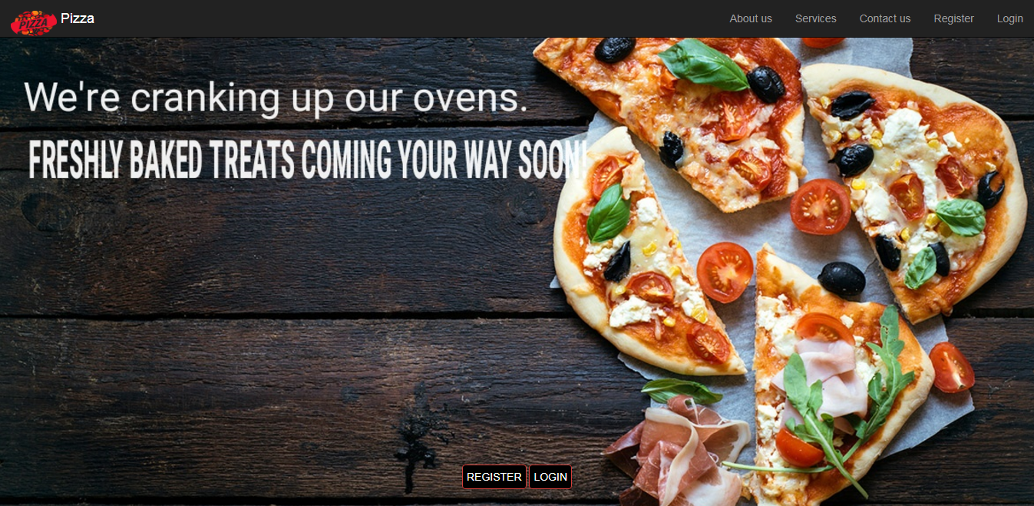

**Fig 2: Home Page**

**About us section:**

This is a section on the Home page containing information about the company.

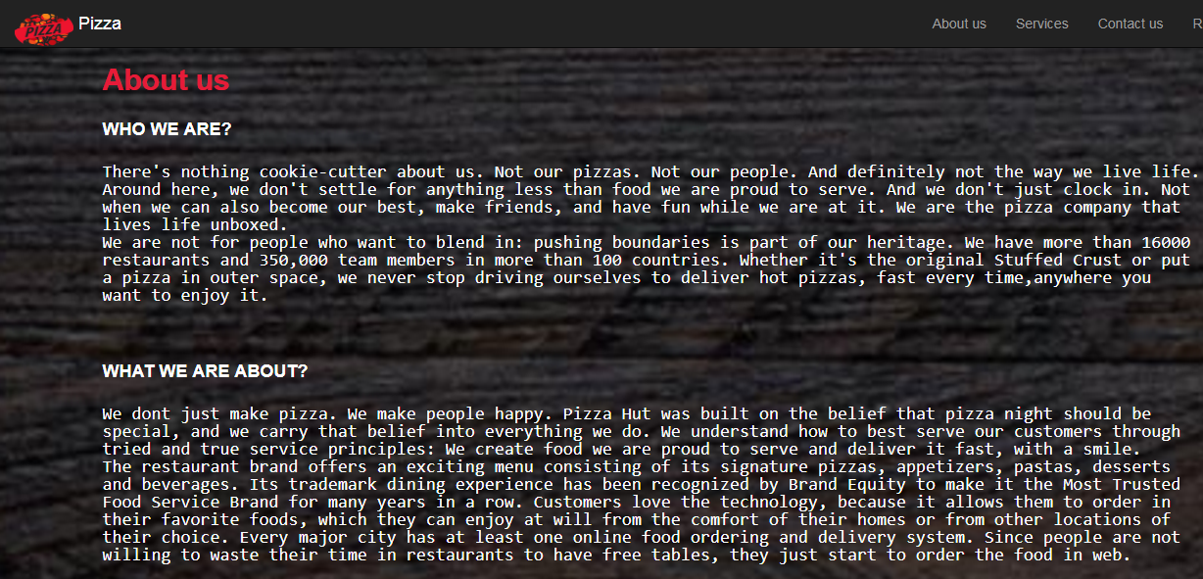

**Fig 3: About us Section**

**Services section:**

This is a section on the Home Page containing services provided by the company.

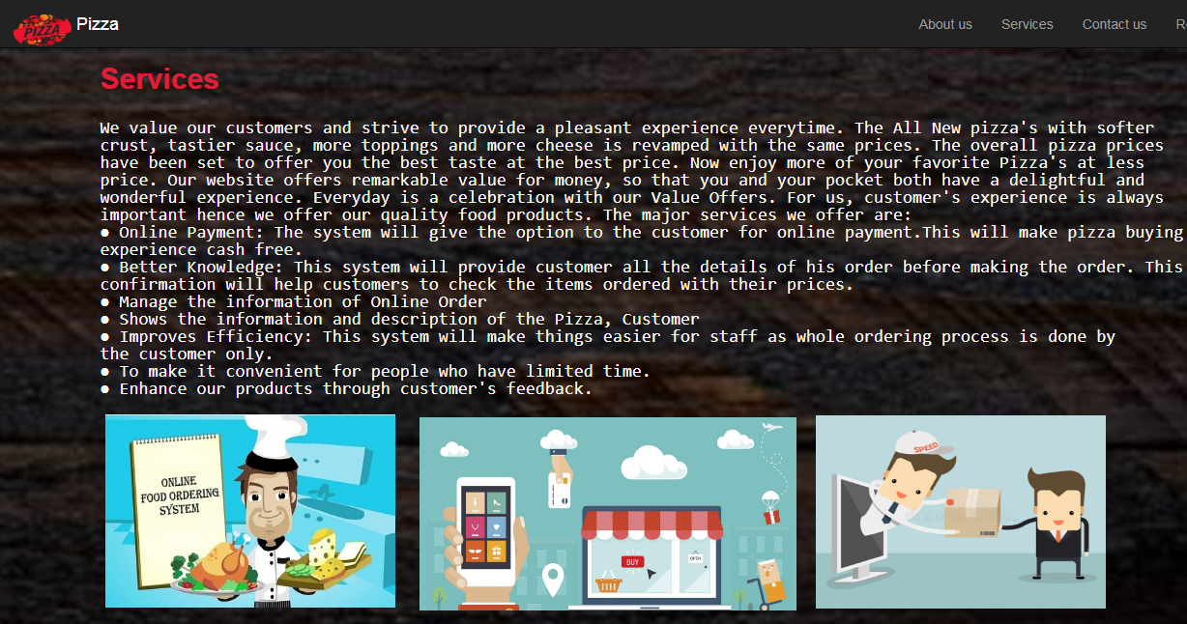

**Fig 4: Services section**

**Contact us section:**

This is a section on Home Page containing contact information of the company.

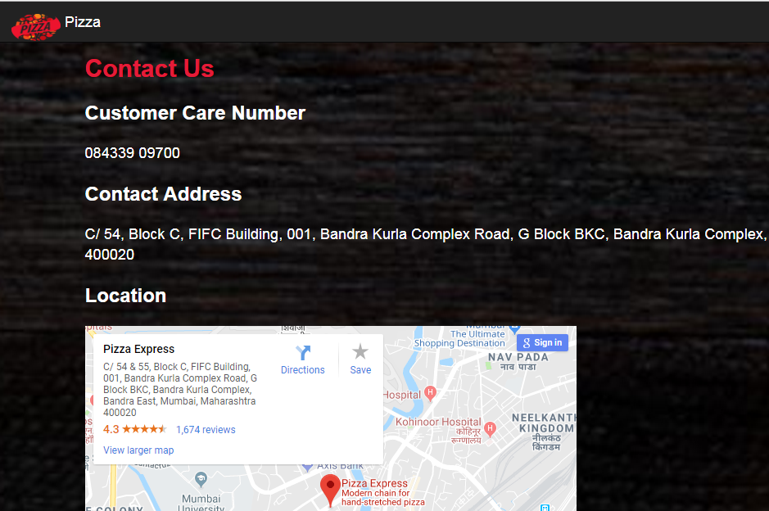

**Fig 5: Contact us section**

**Register Page:**

The Home Page is provided with a form wherein the user has to enter all his details before he can log in to the website. It is also provided with a nav-bar having a logo, a name and a home button, each of which redirects the user to the Home Page.

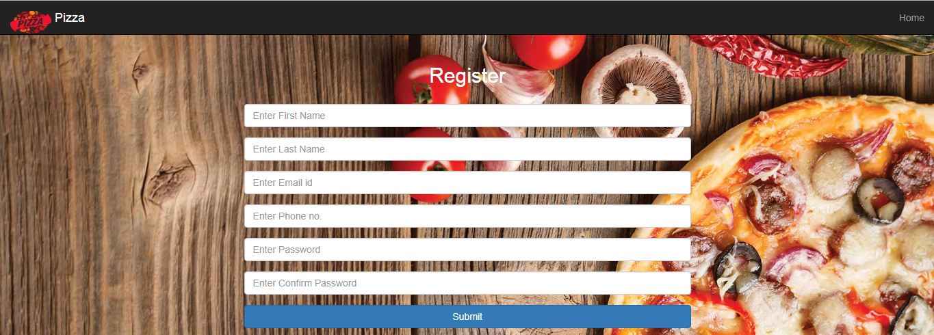

**Fig 6: Register Page**

**Login Page:**

The Login Page provides a form for a registered user to log in to his account. The nav-bar is same as that of Register Page.

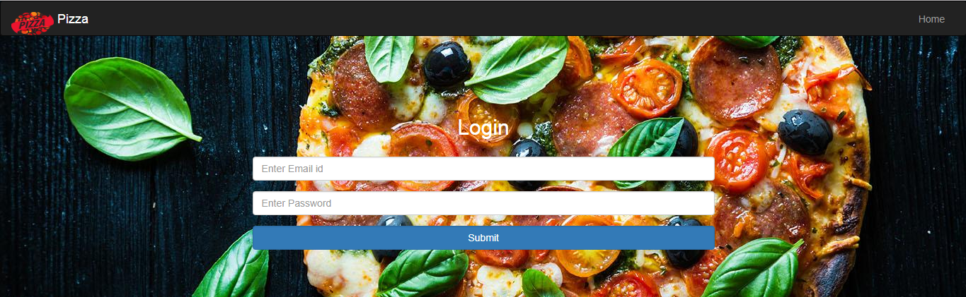 **Fig 7: Login Page**

**Account Page:**

The account page has three tabs: Veg. Pizza, Non- Veg. Pizza, Add Money to Your Wallet and Account Information. The nav-bar has a Logout button for logging out of the account. These tabs are discussed as shown below:

Veg. Pizza tab:

This is a tab for ordering Veg. Pizza.

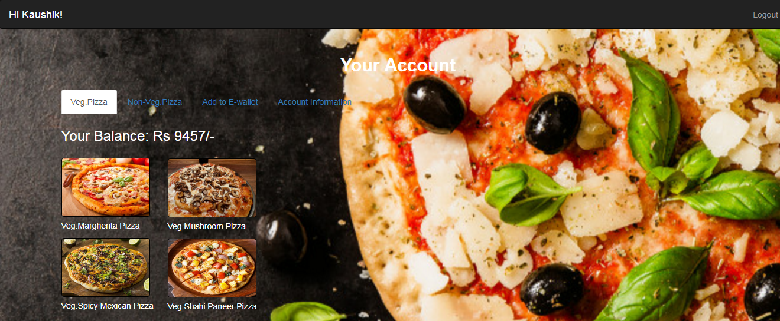

**Fig 8: Veg.Pizza tab**

Non-Veg. Pizza tab:

This is a tab for ordering Non-veg. pizza.

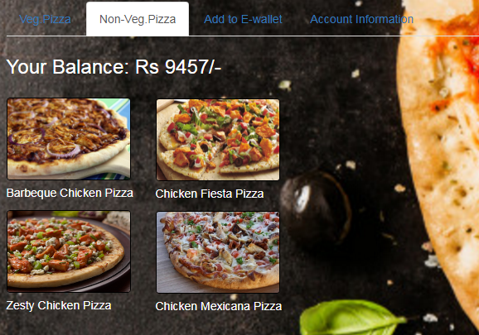

**Fig 9: Non-Veg.Pizza tab**

Add to E-wallet:

This is a tab for adding money to E-wallet

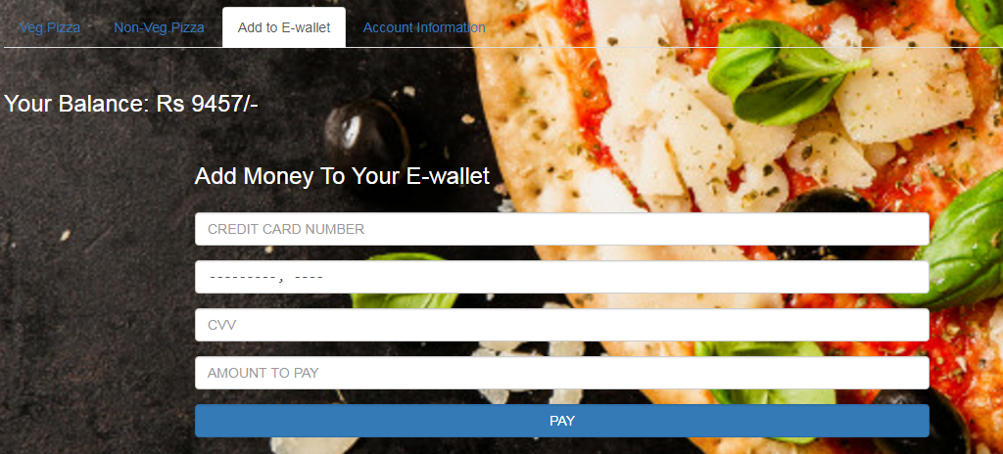

**Fig 10: Add to E-wallet tab**

Account Information:

This is a tab showing account information of user.

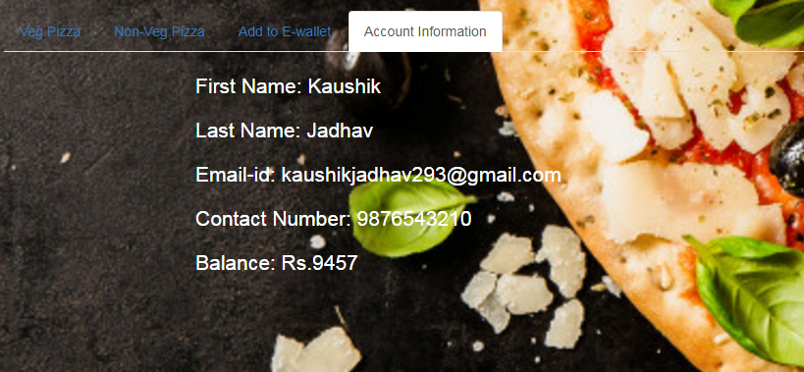

**Fig 11: Account Information**

**Feedback Page:**

The Feedback Page is provided with a text box for the customer to provide the suitable feedback.

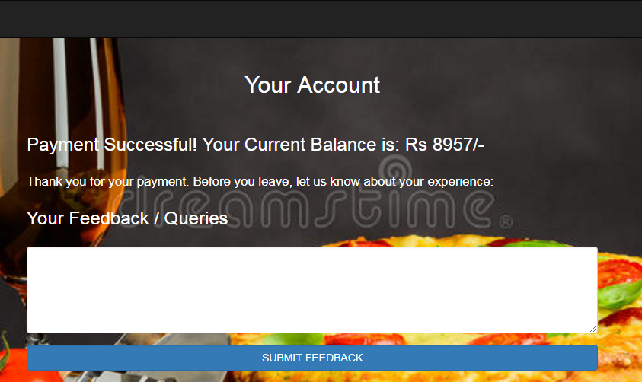

**Fig 12: Feedback Page**

**1.8 Test Cases (Screenshots of errors occurred):**

**Test cases for register page:**

Expected result:

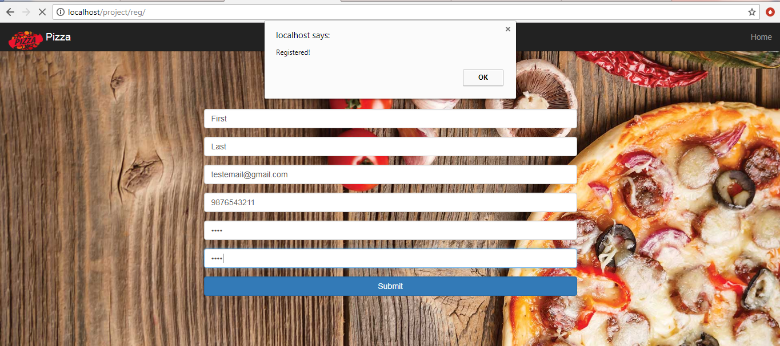

**Fig 13: Expected Register Page**

Case 1: Result obtained if any field is left blank:

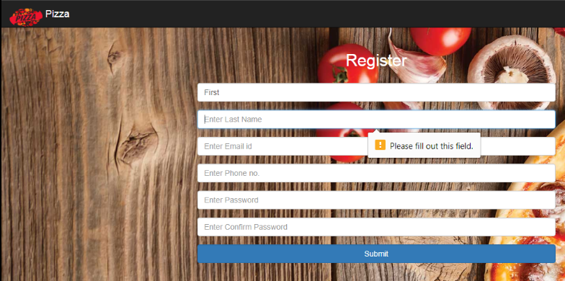

**Fig 14: Register Page Case 1**

Case 2: Result obtained if primary key(email or contact number)is repeated:

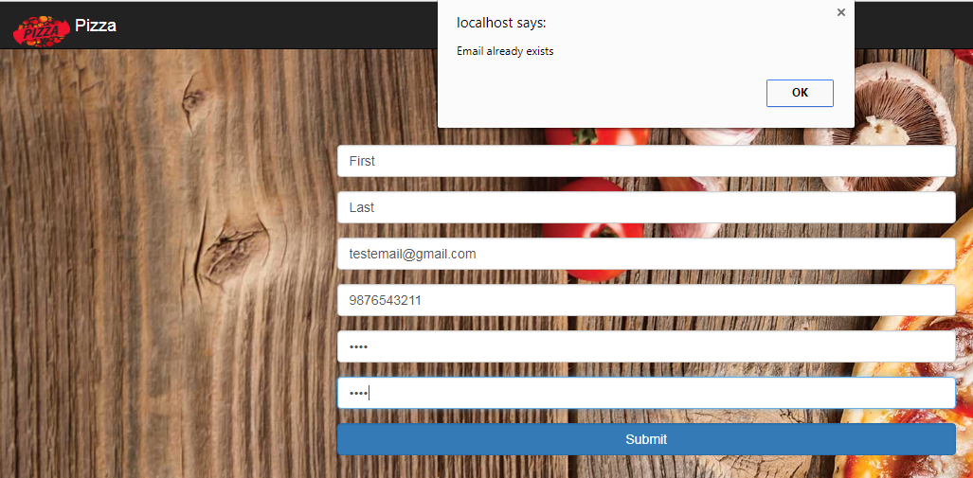

**Fig 15: Register Page Case 2**

Case 3: Result obtained if primary key email-id or contact number is invalid:

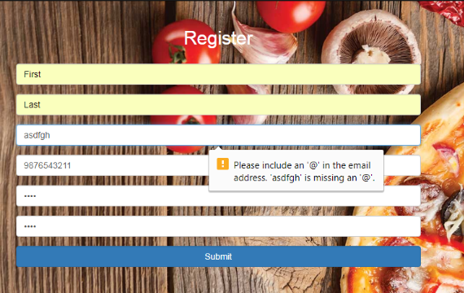

**Fig 16: Register Page Case 3**

Case 4: Result obtained if password and confirm password do not match:

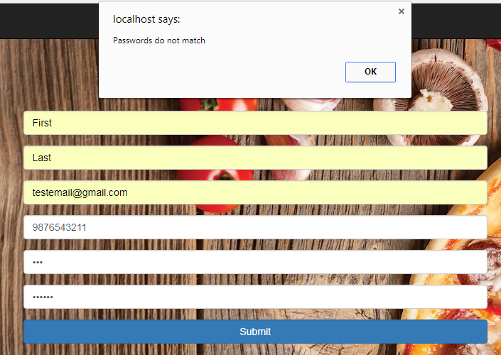

**Fig 17: Register Page Case 4**

**Test cases for Login page:**

Expected result:

Forwards the user to his account page.

Case 1: Results obtained if any field is left blank:

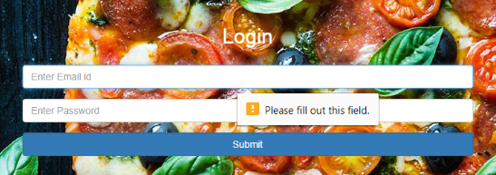

**Fig 18: Login Page Case 1**

Case 2: Results obtained if username or password is invalid:

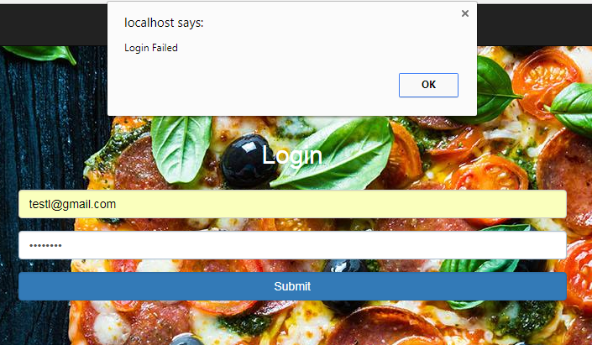

**Fig 19: Login Page Case 2**

**Test cases for confirmation(order) page:**

Expected Result:

Forwards the user to feedback page.

Case 1: If payment is greater than balance in E-wallet:

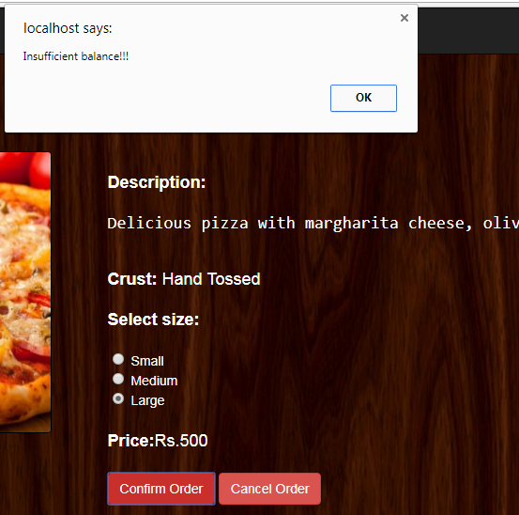

**Fig 20: Confirmation Page Case 1**

**Test cases for account(E-wallet) page:**

Expected Result:

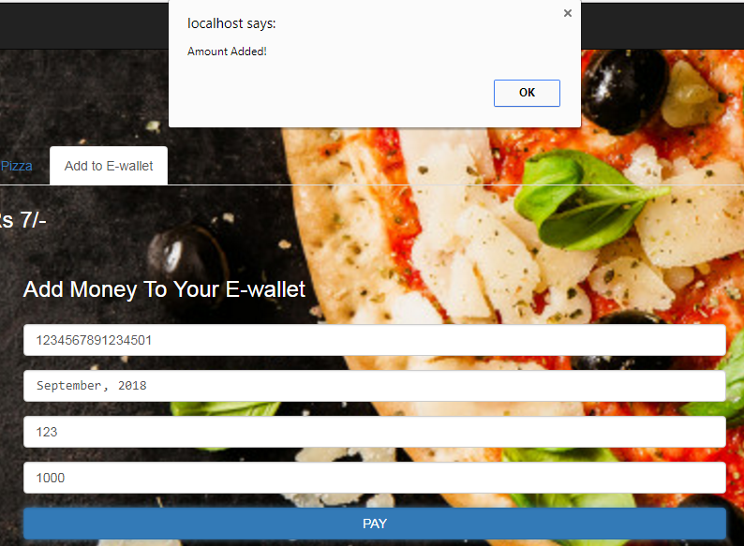

**Fig 21: Expected Account Page**

Case 1: Results obtained if any field is blank:

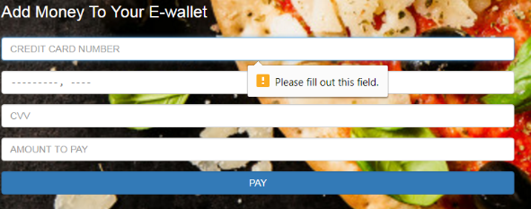

**Fig 22: Account Page Case 1**

Case 2: Results obtained if Credit Card Number or CVV is invalid:

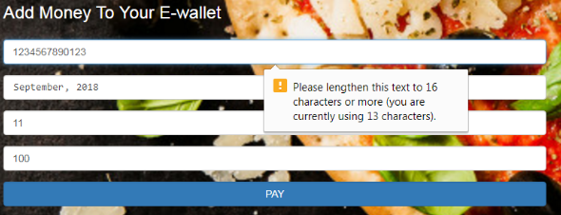

**Fig 23: Account Page Case 2**

## Hardware Interfaces

No hardware interfaces have been identified.

## Software Interfaces

SI-1: Pizza Ordering Inventory System

SI-1.1: The COS shall transmit the quantities of food items ordered to the Pizza Ordering Inventory System through a programmatic interface.

SI-1.2: The COS shall poll the Pizza Ordering Inventory System to determine whether a requested food item is available.

SI-1.3: When the Pizza Ordering Inventory System notifies the COS that a specific food item is no longer available, the COS shall remove that food item from the menu for the current date.

SI-2: Payroll System

The COS shall communicate with the Payroll System through a programmatic interface for the following operations:

SI-2.1: To allow a Patron to register for payroll deduction.

SI-2.2: To allow a Patron to unregister for payroll deduction.

SI-2.3: To check whether a patron is registered for payroll deduction.

SI-2.4: To submit a payment request for a purchased meal.

SI-2.5: To reverse all or part of a previous charge because a patron rejected a meal or wasn’t satisfied with it, or because the meal was not delivered per the confirmed delivery instructions.

## Communications Interfaces

CI-1: The Pizza Ordering Ordering System shall send an e-mail message to the Patron to confirm acceptance of an order, price, and delivery instructions.

CI-2: The Pizza Ordering Ordering System shall send an e-mail message to the Patron to report any problems with the meal order or delivery after the order is accepted.

# System Features

## Order Meals

**4.1.1 Description and Priority**

A Pizza Ordering Patron whose identity has been verified may order meals either to be delivered to a specified company location or to be picked up in the Pizza Ordering. A Patron may cancel or change a meal order if it has not yet been prepared. Priority = High.

**4.1.2 Stimulus/Response Sequences**

Stimulus: Patron requests to place an order for one or more meals.

Response: System queries Patron for details of meal(s), payment, and delivery instructions.

Stimulus: Patron requests to change a meal order.

Response: If status is “Accepted,” system allows user to edit a previous meal order.

Stimulus: Patron requests to cancel a meal order.

Response: If status is “Accepted, ”system cancels a meal order.

**4.1.3 Functional Requirements**

|  |
| --- |
| Order.Place: The system shall let a Patron who is logged into the Pizza Ordering Ordering System place an order for one or more meals.  Order.Place.Register: The system shall confirm that the Patron is registered for payroll deduction to place an order.  Order.Place.Register.No If the Patron is not registered for payroll deduction, the system shall give the Patron options to register now and continue placing an order, to place an order for pickup in the Pizza Ordering (not for delivery), or to exit from the COS.  Order.Place.Date: The system shall prompt the Patron for the meal date (see BR-8).  Order.Place.Date.Cutoff: If the meal date is the current date and the current time is after the order cutoff time, the system shall inform the patron that it’s too late to place an order for today. The Patron may either change the meal date or cancel the order. |
| Order.Deliver.Select: The Patron shall specify whether the order is to be picked up or delivered.  Order.Deliver.Location: If the order is to be delivered and there are still available delivery times for the meal date, the Patron shall provide a valid delivery location.  Order.Deliver.Notimes: The system shall notify the Patron if there are no available delivery times for the meal date. The Patron shall either cancel the order or indicate that the Patron will pick up the order in the Pizza Ordering.  Order.Deliver.Times: The system shall display the remaining available delivery times for the meal date. The system shall allow the Patron to request one of the delivery times shown, to change the order to be picked up in the Pizza Ordering, or to cancel the order. |
| Order.Menu.Date: The system shall display a menu for the specified date.  Order.Menu.Available: The menu for the current date shall display only those food items for which at least one unit is available in the Pizza Ordering’s inventory. |
| Order.Units.Food: The system shall allow the Patron to indicate the number of units of each menu item that he wishes to order.  Order.Units.Multiple: The system shall permit the user to order multiple identical meals, up to the fewest available units of any menu item in the order.  Order.Units.TooMany: If the Patron orders more units of a menu item than are presently in the Pizza Ordering’s inventory, the system shall inform the Patron of the maximum number of units of that food item that he can order.  Order.Units.Change: If the available inventory cannot fulfill the number of units ordered, the Patron may change the number of units ordered, change the number of identical meals being ordered, or cancel the meal order. |
| Order.Confirm.Display: When the Patron indicates that he does not wish to order any more food items, the system shall display the food items ordered, the individual food item prices, and the payment amount, calculated per BR-12.  Order.Confirm.Prompt: The system shall prompt the Patron to confirm the meal order.  Order.Confirm.Not: If the Patron does not confirm the meal order, the Patron may either edit or cancel the order.  Order.Confirm.More: The system shall let the Patron order additional meals for the same or for different date. BR-3 and BR-4 pertain to multiple meals in a single order. |
| Order.Pay.Method: When the Patron indicates that he is done placing orders, the system shall ask the user to select a payment method.  Order.Pay.Deliver: See BR-11.  Order.Pay.Pickup: If the meal is to be picked up in the Pizza Ordering, the system shall let the Patron choose to pay by payroll deduction or by paying cash at the time of pickup.  Order.Pay.Details: The system shall display the food items ordered, payment amount, payment method, and delivery instructions.  Order.Pay.Confirm: The Patron shall either confirm the order, request to edit the order, or request to cancel the order.  Order.Pay.Confirm.Deduct: If the Patron confirmed the order and selected payment by payroll deduction, the system shall issue a payment request to the Payroll System.  Order.Pay.Confirm.OK: If the payment request is accepted, the system shall display a message confirming acceptance of the order with the payroll deduction transaction number.  Order.Pay.Confirm.NG: If the payment request is rejected, the system shall display a message with the reason for the rejection. The Patron shall either cancel the order, or change the payment method to cash and request to pick up the order at the Pizza Ordering. |
| Order.Done: When the Patron has confirmed the order, the system shall do the following as a single transaction:  Order.Done.Store Assign the next available meal order number to the meal and store the meal order with an initial status of “Accepted.”  Order.Done.Inventory: Send a message to the Pizza Ordering Inventory System with the number of units of each food item in the order.  Order.Done.Menu: Update the menu for the current order’s order date to reflect any items that are now out of stock in the Pizza Ordering inventory.  Order.Done.Times: Update the remaining available delivery times for the date of this order.  Order.Done.Patron: Send an e-mail message to the Patron with the meal order and meal payment information.  Order.Done.Pizza Ordering: Send an e-mail message to the Pizza Ordering Staff with the meal order information.  Order.Done.Failure: If any step of Order.Done fails, the system shall roll back the transaction and notify the user that the order was unsuccessful, along with the reason for failure. |
| Order.Previous.Period: The system shall permit the Patron to view any meals he has ordered within the previous six months. [Priority = Medium]  Order.Previous.Reorder: The Patron may reorder any meal he had ordered within the previous six months, provided that all food items in that order are available on the menu for the meal date. [Priority = Medium] |
| *[functional requirements for changing and canceling meal orders are not provided in this example]* |

## Create, View, Modify, and Delete Meal Subscriptions

### Description and Priority

In today’s modern world, customers expect that new food trends are available in their favorite food ordering websites. In order to meet the varying trends in the food world and changing customer requirements, it is necessary to create, view, modify and delete meal subscriptions from our food ordering portal.

### Functional Requirements

In order to provide the above mentioned functionality, it is necessary to satisfy certain functional requirements as specified below:

**Hardware Requirements:**

Computer hardware refers to the physical parts of a computer and related devices. The hardware resources required by an operating system or software application to function properly are known as hardware requirements. The hardware requirements of our project are summarized in the table given below:

**Table 2: Hardware Requirements**

|  |  |
| --- | --- |
| **Parameter** | **Description** |
| Hardware | Pentium or advanced versions |
| Speed | 1.1 GHz or higher |
| RAM | 1GB or higher |
| Hard Disk | 20 GB or higher |
| Floppy Drive | 1.44 MB or higher |
| Key Board | Standard Windows Keyboard or higher |
| Mouse | Two or Three Button Mouse |
| Monitor | SVGA or advanced versions |

**Software Requirements:**

Software is a collection of instructions that enable the user to interact with a computer, its hardware, or perform tasks. The software resources required to perform a desired task are known as software requirements. The software requirements of our project are summarized in the table given below:

**Table 3: Software Requirements**

|  |  |
| --- | --- |
| **Parameter** | **Description** |
| Operating System | Windows |
| Scripting Technology | PHP |
| Web Technologies | HTML, JavaScript, CSS |
| IDE | Notepad++ or higher |
| Web Server | Wamp2.2e or higher |
| Database | MySQL |

# Other Nonfunctional Requirements

## Performance Requirements

PE-1: The system shall accommodate 400 users during the peak usage time window of 8:00am to 10:00am local time, with an estimated average session duration of 8 minutes.

PE-2: All Web pages generated by the system shall be fully downloadable in no more than 10 seconds over a 40KBps modem connection.

PE-3: Responses to queries shall take no longer than 7 seconds to load onto the screen after the user submits the query.

PE-4: The system shall display confirmation messages to users within 4 seconds after the user submits information to the system.

## Safety Requirements

No safety requirements have been identified.

## Security Requirements

SE-1: All network transactions that involve financial information or personally identifiable information shall be encrypted per BR-33.

SE-2: Users shall be required to log in to the Pizza Ordering Ordering System for all operations except viewing a menu.

SE-3: Patrons shall log in according to the restricted computer system access policy per BR-35.

SE-4: The system shall permit only Pizza Ordering staff members who are on the list of authorized Menu Managers to create or edit menus, per BR-24.

SE-5: Only users who have been authorized for home access to the corporate Intranet may use the COS from non-company locations.

SE-6: The system shall permit Patrons to view only their own previously placed orders, not orders placed by other Patrons.

## Software Quality Attributes

Availability-1: The Pizza Ordering Ordering System shall be available to users on the corporate Intranet and to dial-in users 99.9% of the time between 5:00am and midnight local time and 95% of the time between midnight and 5:00am local time.

Robustness-1: If the connection between the user and the system is broken prior to an order being either confirmed or canceled, the Pizza Ordering Ordering System shall enable the user to recover an incomplete order.

# Other Requirements

**6.1 Licensing Requirements**

Not Applicable

**6.2 Legal, Copyright, and Other Notices**

All right reserved by our team.

**6.3 Applicable Standards**

It should be as per the industry standard.

Appendix A: Data Dictionary and Data Model

|  |  |  |
| --- | --- | --- |
| delivery instruction | =  +  +  +  + | patron name  patron phone number  meal date  delivery location  delivery time window |
| delivery location | = | * building and room to which an ordered meal is to be delivered * |
| delivery time window | = | * 15-minute range during which an ordered meal is to be delivered; must begin and end on quarter-hour intervals * |
| employee ID | = | * company ID number of the employee who placed a meal order; 6-character numeric string * |
| food item description | = | * text description of a food item on a menu; maximum 100 characters * |
| food item price | = | * pre-tax cost of a single unit of a menu food item, in dollars and cents * |
| meal date | = | * the date the meal is to be delivered or picked up; format MM/DD/YYYY; default = current date if the current time is before the order cutoff time, else the next day; may not be prior to the current date * |
| meal order | =  +  +  +  +  + | meal order number  order date  meal date  1:m{ordered food item}  delivery instruction  meal order status |
| meal order number | = | * a unique, sequential integer that the system assigns to each accepted meal order; initial value is 1 * |
| meal order status | = | [ incomplete | accepted | prepared | pending delivery | delivered | canceled ] * see state-transition diagram in Appendix B * |
| meal payment | =  +  + | payment amount  payment method  (payroll deduction transaction number) |
| menu | =  +  + | menu date  1:m{menu food item}  0:1{special} |
| menu date | = | * the date for which a specific menu of food items is available; format MM/DD/YYYY * |
| menu food item | =  + | food item description  food item price |
| order cutoff time | = | * the time of day before which all orders for that date must be placed * |
| order date | = | * the date on which a patron placed a meal order; format MM/DD/YYYY * |
| ordered food item | =  + | menu food item  quantity ordered |
| patron | =  +  +  +  + | patron name  employee ID  patron phone number  patron location  patron e-mail |
| patron e-mail | = | * e-mail address of the employee who placed a meal order; 50 character alphanumeric * |
| patron location | = | * building and room numbers of the employee who placed a meal order; 50 character alphanumeric * |
| patron name | = | * name of the employee who placed a meal order; 30 character alphanumeric * |
| patron phone number | = | * telephone number of the employee who placed a meal order; format AAA-EEE-NNNN xXXXX for area code, exchange, number, and extension * |
| payment amount | = | * total price of an order in dollars and cents, calculated per BR-12 * |
| payment method | = | [ payroll deduction | cash ] * others to be added beginning with release 2 * |
| payroll deduction transaction number | = | * 8-digit sequential integer number that the Payroll System assigns to each payroll deduction transaction that it accepts * |
| quantity ordered | = | * the number of units of each food item that the Patron is ordering; default = 1; maximum = quantity presently in inventory * |
| special | =  + | special description  special price  * the Menu Manager may define one or more special meals for each menu, with a particular combination of food items at a reduced price * |
| special description | = | * text description of a daily special meal; maximum 100 characters * |
| special price | = | * cost of a single unit of a daily special meal, in dollars and cents * |

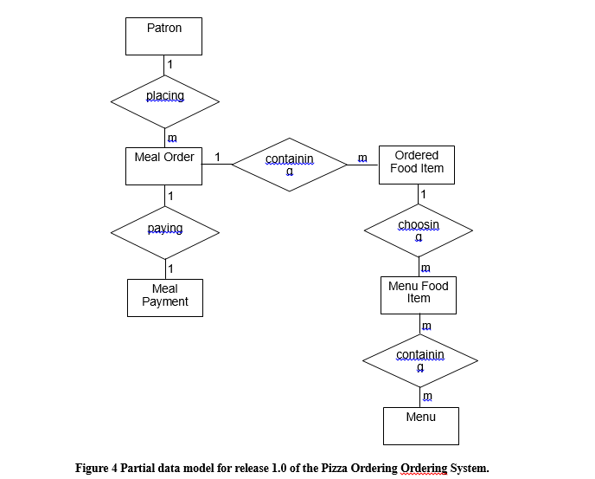

Appendix B: Analysis Models

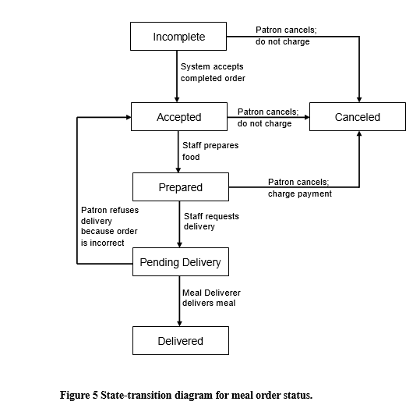

**Chapter 3: Analysis and Design Engineering**

**3.1 Use Case Diagram:**

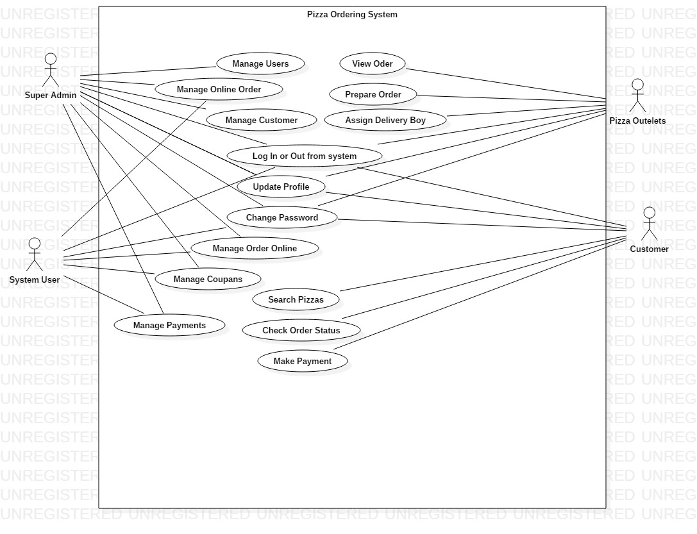

Fig 3.1: Use Case Diagram

**Explanation:**

This Use Case Diagram is a graphic depiction of the interactions among the elements of Pizza Ordering System. It represents the methodology used in system analysis to identify, clarify, and organize system requirements of Pizza Ordering System. The main actors of Pizza Ordering System in this Use Case Diagram are: Super Admin, System User, Pizza Outlets, Customers, who perform the different type of use cases such as Manage Pizza, Manage Online Order, Manage Customer, Manage Order Status, Manage Coupans, Manage Payments, Manage Users and Full Pizza Ordering System Operations. Major elements of the UML use case diagram of Pizza Ordering System are shown on the picture below.

**The relationships between and among the actors and the use cases of Pizza Ordering System:**

**Super Admin Entity**: Use cases of Super Admin are Manage Pizza, Manage Online Order, Manage Customer, Manage Order Status, Manage Coupans, Manage Payments, Manage Users and Full Pizza Ordering System Operations

**System User Entity**: Use cases of System User are Manage Pizza, Manage Online Order, Manage Customer, Manage Order Status, Manage Coupans, Manage Payments

**Pizza Outlets Entity**: Use cases of Pizza Outlets are View Orders, Preapare Orders, Assing Delivery Boy, Collect Payments

**Customers Entity**: Use cases of Customers are Search Pizzas, Add to Cart, Make Payment, Check Order Status

**3.2 Class Diagram:**

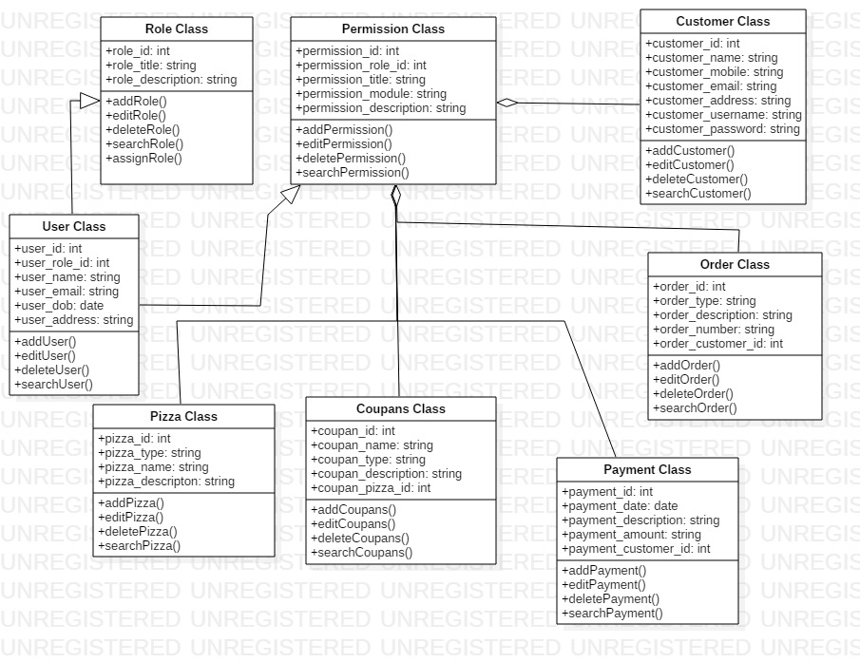

Fig 3.2: Class Diagram

**Explanation:**

Pizza Ordering System Class Diagram describes the structure of a Pizza Ordering System classes, their attributes, operations (or methods), and the relationships among objects. The main classes of the Pizza Ordering System are Pizza, Order, Customer, Order Status, Coupans, Payments.

**Classes of Pizza Ordering System Class Diagram:**

* **Pizza Class** : Manage all the operations of Pizza
* **Order Class** : Manage all the operations of Order
* **Customer Class** : Manage all the operations of Customer
* **Order Status Class** : Manage all the operations of Order Status
* **Coupans Class** : Manage all the operations of Coupans
* **Payments Class** : Manage all the operations of Payments

**Classes and their attributes of Pizza Ordering System Class Diagram:**

* **Pizza Attributes** : pizza_id, pizza_name, pizza_type, pizza_description
* **Order Attributes** : order_id, order_customer_id order_type, order_number, order_description
* **Customer Attributes** : customer_id, customer_name, customer_mobile, customer_email, customer_username, customer_password, customer_address
* **Order Status Attributes** : status_id, status_order_id, status_name, status_update, status_time, status_date, status_type, status_description
* **Coupans Attributes** : coupan_id, coupan_pizza_id, coupan_name, coupan_type, coupan_description
* **Payments Attributes** : payment_id, payment_customer_id, payment_date, payment_amount, payment_description

**Classes and their methods of Pizza Ordering System Class Diagram:**

* **Pizza Methods** : addPizza(), editPizza(), deletePizza(), updatePizza(), savePizza(), searchPizza()
* **Order Methods** : addOrder(), editOrder(), deleteOrder(), updateOrder(), saveOrder(), searchOrder()
* **Customer Methods** : addCustomer(), editCustomer(), deleteCustomer(), updateCustomer(), saveCustomer(), searchCustomer()
* **Order Status Methods** : addOrder Status(), editOrder Status(), deleteOrder Status(), updateOrder Status(), saveOrder Status(), searchOrder Status()
* **Coupans Methods** : addCoupans(), editCoupans(), deleteCoupans(), updateCoupans(), saveCoupans(), searchCoupans()
* **Payments Methods** : addPayments(), editPayments(), deletePayments(), updatePayments(), savePayments(), searchPayments()

**3.3 Object Diagram:**

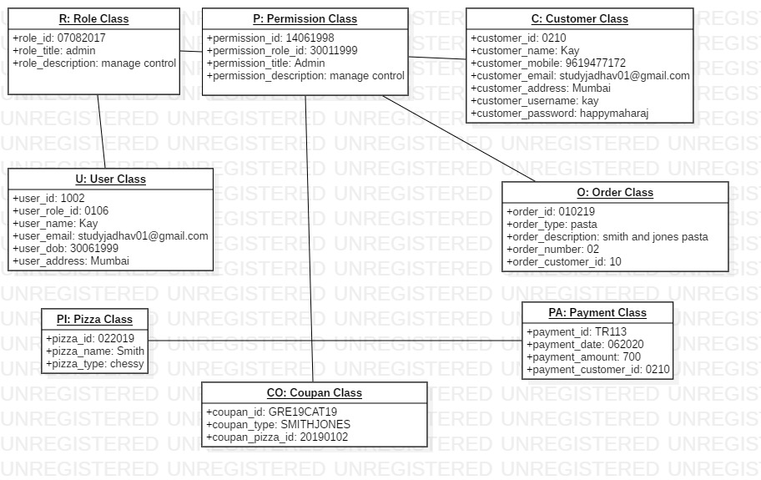

Fig 3.3: Object Diagram

**Explanation:**

Pizza Ordering System Object Diagram describes the structure of a Pizza Ordering System classes, their attributes, operations (or methods), and the relationships among objects. The main classes of the Pizza Ordering System are Pizza, Order, Customer, Order Status, Coupans, Payments.

**Classes of Pizza Ordering System Class Diagram:**

* **Pizza Class** : Manage all the operations of Pizza
* **Order Class** : Manage all the operations of Order
* **Customer Class** : Manage all the operations of Customer
* **Order Status Class** : Manage all the operations of Order Status
* **Coupans Class** : Manage all the operations of Coupans
* **Payments Class** : Manage all the operations of Payments

**Classes and their attributes of Pizza Ordering System Class Diagram:**

* **Pizza Attributes** : pizza_id, pizza_name, pizza_type, pizza_description
* **Order Attributes** : order_id, order_customer_id order_type, order_number, order_description
* **Customer Attributes** : customer_id, customer_name, customer_mobile, customer_email, customer_username, customer_password, customer_address
* **Order Status Attributes** : status_id, status_order_id, status_name, status_update, status_time, status_date, status_type, status_description
* **Coupans Attributes** : coupan_id, coupan_pizza_id, coupan_name, coupan_type, coupan_description
* **Payments Attributes** : payment_id, payment_customer_id, payment_date, payment_amount, payment_description

**3.4 Sequence Diagram:**

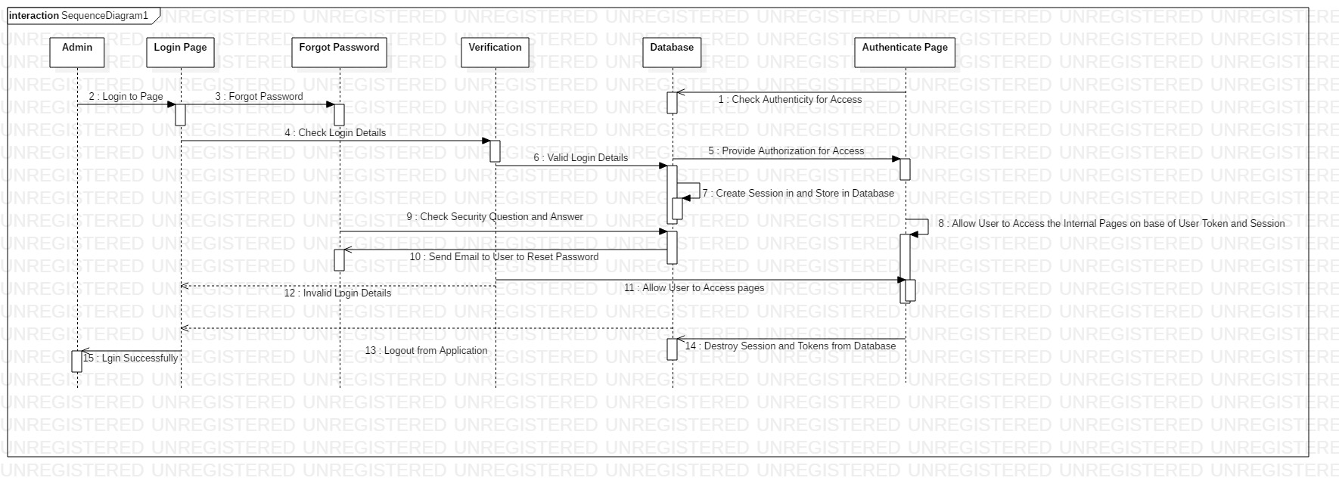

Fig 3.4: Sequence Diagram

**Explanation:**

This is the **UML sequence diagram of Pizza Ordering System** which shows the interaction between the objects of Payments, Customer, Order, Pizza, Coupans. The instance of class objects involved in this UML Sequence Diagram of Pizza Ordering System are as follows:

* Payments Object
* Customer Object
* Order Object
* Pizza Object
* Coupans Object

**3.5 Collaboration Diagram:**

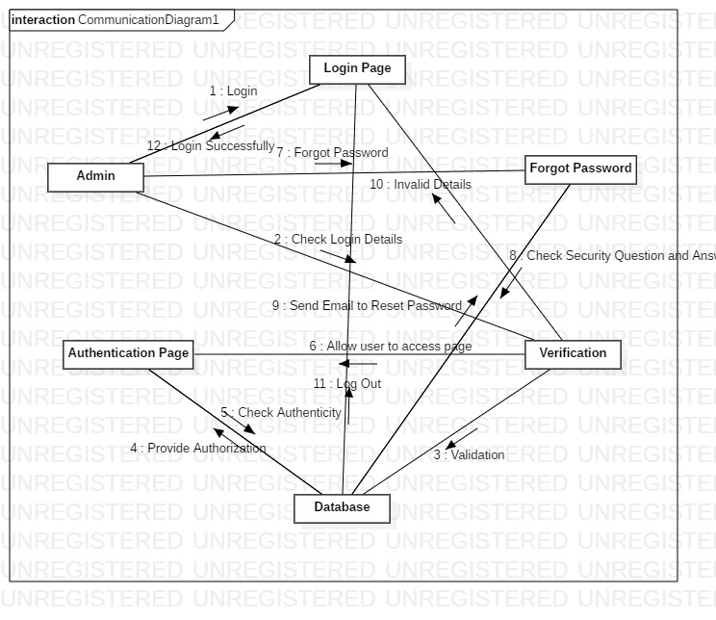

Fig 3.5: Collaboration Diagram

**Explanation:**

This is the **UML Collaboration diagram of Pizza Ordering System** which shows the interaction between the objects of Payments, Customer, Order, Pizza, Coupans. The instance of class objects involved in this UML Sequence Diagram of Pizza Ordering System are as follows:

* Payments Object
* Customer Object
* Order Object
* Pizza Object
* Coupans Object

**3.6 Activity Diagram:**

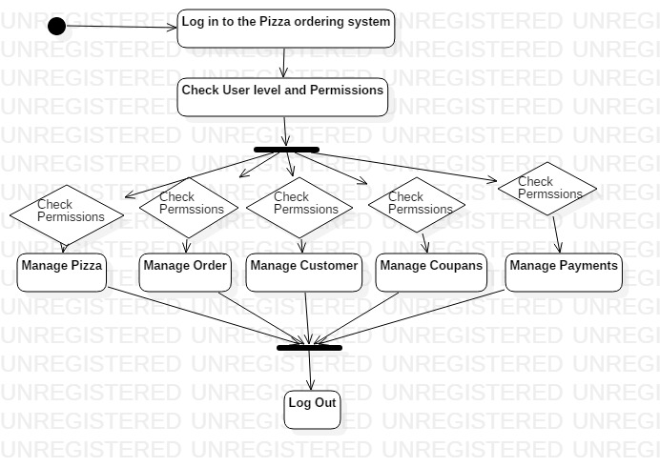

Fig 3.6: Activity Diagram

**Explanation:**

This is the Activity UML diagram of Pizza Ordering System which shows the flows between the activity of Pizza, Payments, Customer, Coupans, Order. The main activity involved in this UML Activity Diagram of Pizza Ordering System are as follows:

* Pizza Activity
* Payments Activity
* Customer Activity
* Coupans Activity
* Order Activity

**Features of the Activity UML diagram of Pizza Ordering System:**

* Admin User can search Pizza, view description of a selected Pizza, add Pizza, update Pizza and delete Pizza.
* Its shows the activity flow of editing, adding and updating of Payments
* User will be able to search and generate report of Customer, Coupans, Order
* All objects such as (Pizza, Payments, Order) are interlinked
* Its shows the full description and flow of Pizza, Coupans, Order, Customer, Payments

**3.7 State Diagram:**

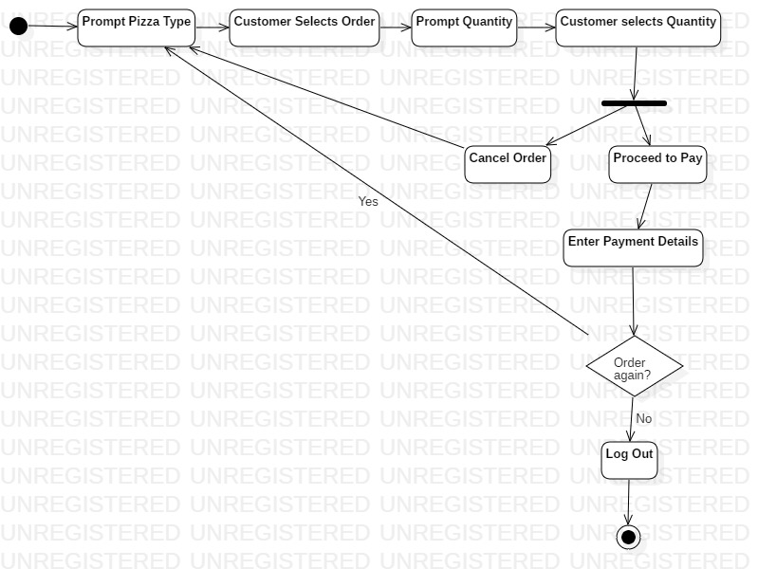

Fig 3.7: State Diagram

**Explanation:**

The State Chart Diagram shows various states that the system and user undergo during its operation. Initially, the system prompts a menu for various types of available pizzas. After the customer selects his order, the system will then prompt quantity of the order. After the customer selects quantity, he may either proceed to pay and enter his payment credentials. Or, he may cancel the order and go back to select a different order. Then, the customer is prompted to either order again or to Log Out of the system.

**3.8 Component Diagram:**

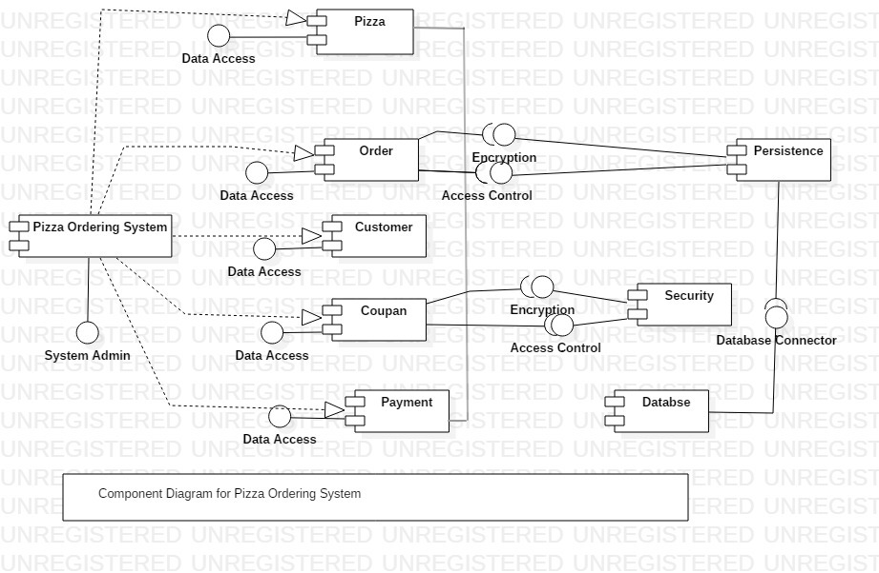

Fig 3.8: Component Diagram

**Explanation:**

This is a **Component diagram of Pizza Ordering System** which shows components, provided and required interfaces, ports, and relationships between the Customer, Payments, Order, Coupans and Pizza. This type of diagrams is used in Component-Based Development (CBD) to describe systems with Service-Oriented Architecture (SOA). **Pizza Ordering System UML component diagram**, describes the organization and wiring of the physical components in a system.

**Components of UML Component Diagram of Pizza Ordering System:**

* Customer Component
* Payments Component
* Order Component
* Coupans Component
* Pizza Component

**Features of Pizza Ordering System Component Diagram:**

* You can show the models the components of Pizza Ordering System.
* Model the database schema of Pizza Ordering System
* Model the executables of an application of Pizza Ordering System

**3.9 Deployment Diagram:**

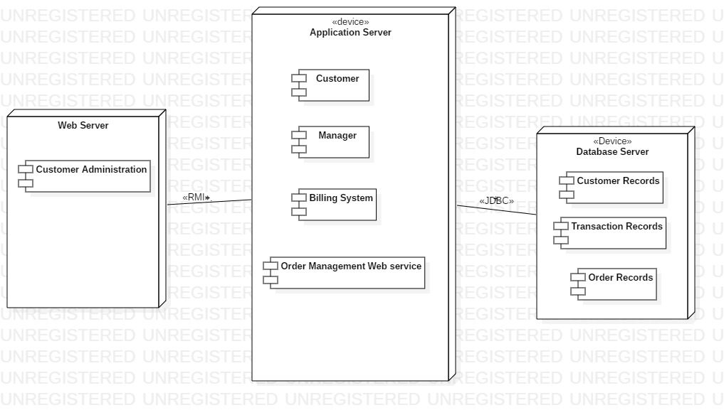

Fig 3.9: Deployment Diagram

**Explanation:**

This diagram represents the deployment plan for the system. The Web server, Application server and Database server are the three key devices in the system. The Web server handles customer administration. The Application server handles interactions between Customer, Manager, Billing System and Order Management web services. The Database server handles all Customer records, Transaction records and Order records.

**3.10 Data Flow Diagram:**

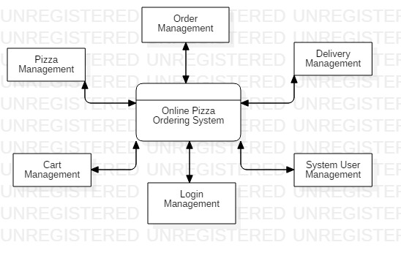

Fig 3.10 Data Flow Diagram Level 0

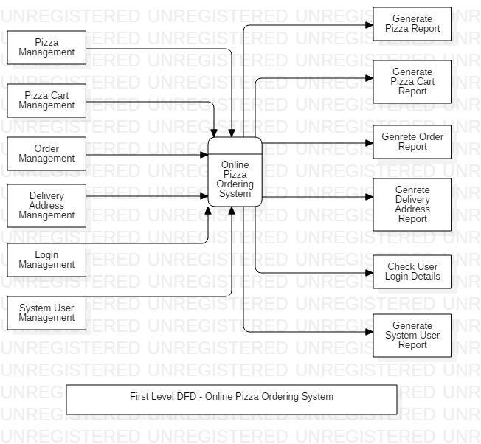

Fig 3.11 Data Flow Diagram Level 1

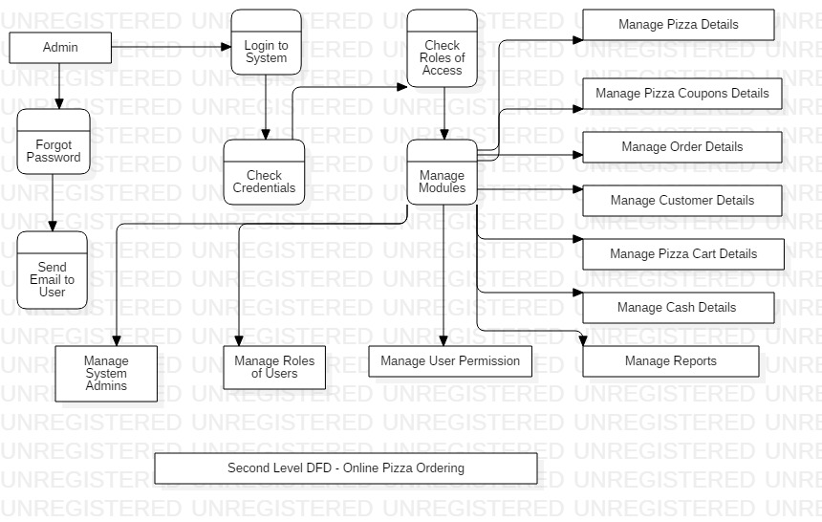

Fig 3.12: Data Flow Diagram Level 2

**3.11 ER Diagram:**

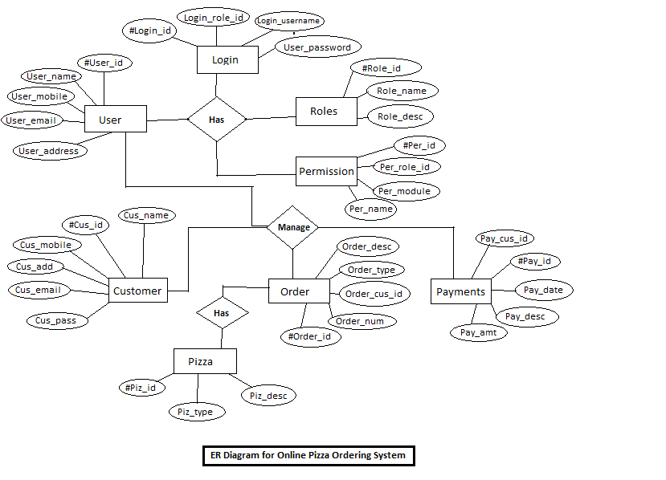

Fig 3.13: ER Diagram

**Chapter 4: Schedule and Cost Estimation**

**4.1 Work Breakdown Structure:**

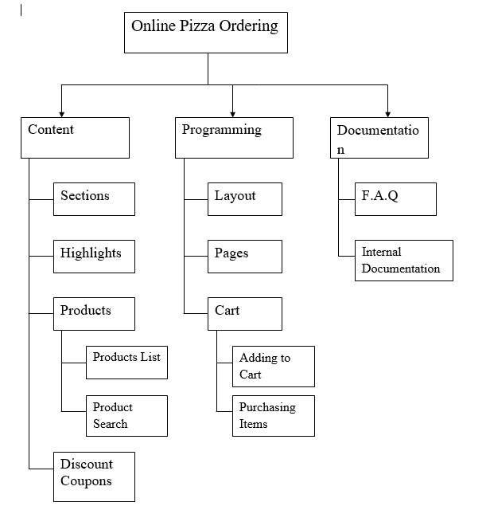

Fig 4.1: Work Breakdown Structure